Siddhanta Shiromani
Grahaganit adhyaya
Suryagrahanadhikar
(Section III, Chapter 3 : Solar Eclipse)

Verse No | Translations
1 | At the end of new moon, although the longitude of sun and moon are equal, a parallax of latitude is observed. As because to an observer on the surface of the earth, elevated by the radius of earth, sun and moon does not seem to be in the same line of sight due to their different orbits, I am explaining in detail the parallax of longitude (Lambana) and parallax of latitude (Nati).
2 | Compute the Lagna at the moment of the conjunction of Sun and Moon (end of the new moon) there will be no parallax in the longitude when the sun is situated at the point called Vitibha whose longitude is L-90° where L=longitude of the Lagna. If Sun’s longitude is less than the Vitribha then the parallax in longitude would be positive and if it exceeds Vitribha then the parallax would be negative. If the parallax is positive add it to the Ghatikas of the end of the Thithi, else subtract it from the Ghatikas of the end of the Thithi.
3-4 | Add the preceding and following Vitribha-Lagna at the end of first contact with the Rashi of their difference to get the rising time for Vitribha. Using this time determine the Dyujyaa, Kujyaa and Antyaa by the method described in Triprashnadhikar Chapter. Find out the Drigjyaa and Hypotenuse of the shadow for the Cone. Find out the sine of Vithribha and longitude of the sun. If the parallax using the radius and the sine of the difference of Vitribha Lagna and the sun’s longitude is 4 Ghatikas then we can use the required sine to find out the mean parallax. Similarly, If the parallax using the radius and the Vitribha Lagna Shanku be the same then we can compute the rectified parallax. Then we would have :  Where V-λ = the difference of Vitribha Lagna and sun’s longitude.
5 | The mean parallax multiplied by 12 and divided by the hypotenuse of the shadow of the Vitribha will also give the rectified parallax.
6 | First determine the Tribhonalagna Shanku and the Drigjyaa of the Sun’s Shanku. Then  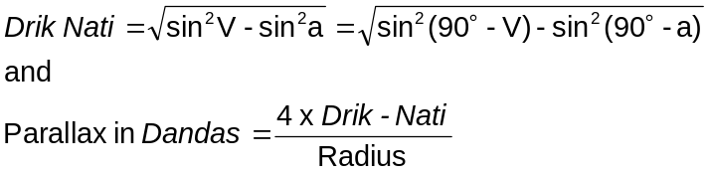  Where V = Vitribha and a = altitude

Verse No | Translations
7 | Alternative method of calculating parallax expressed in Dandas.  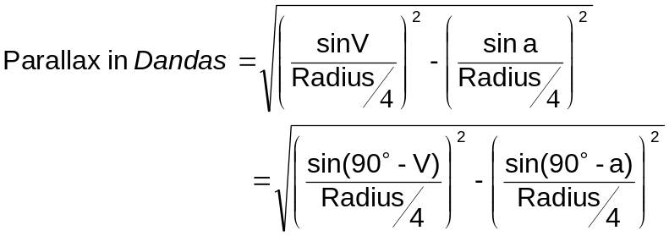  The time of the ending moment of New moon i.e. the moment of geocentric conjunction is to be rectified by this parallax in longitude to get the moment of apparent conjunction by the method of successive approximation.
8-9 | Let Para be defined as  Now determine the sine and cosine of φ =(EET-λ) where EET= Eclipse Ending Time and λ = the longitude of the sun. Hence the Hypotenuse (Karna) would be defined as :  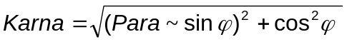  Hence the parallax in longitude would be the arc of  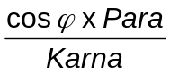
10 | The Drigjyaa of the Vitribha Lagna Shanku is the Drikshepa (shortest arcual distance of the planet’s orbit from the zenith) of the Sun, which is considered to be north in case of northern declination of the Vitribha is greater than the latitude, otherwise south.
11 | Convert Drikshepajyaa as an arc. Now considering the Vitribha Lagna as the moon computer its celestial latitude (Vikshepa) and add the two if they be on the same side or subtract them if they are on the different side. The sine of this gives us the Drikshepa of the Moon.
12 | The Drikshepas of Sun and Moon multiplied respectively by ¹/₁₅ parts of their own daily motions and divided by the radius are the parallaxes of latitude for the sun and the moon. The rectified parallax in latitude of the sun and the moon is given by their difference if they are on the same side and sum if they are on the different side.
13 | Multiply the Drikshepa of the moon by 2 and divide the product by 141 we will have the rectified parallax in celestial latitude. If the Drikshepa of the moon be calculated using the smaller sine table, then the rectified parallax in celestial latitude would be given by :  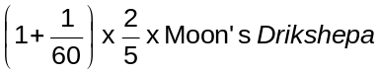  Assuming the Vitribha Lagna as the Longitude of the moon and find out its declination and Shara. Do the correction of the declination with {illegible}. As described in verse no 32 of the Triprashnadhikar Chapter find out the Unnata and Nata. These two sines would lie in the middle Vitribha Lagna and would be the daywise sine of Unnata and Nata.

Verse No | Translations
14 | Take this sine of Unnata as the Vitribha Lagna Shanku and take the sine of Nata as the Drikshep of the Moon and find out the parallax of latitude and longitude.  As described before if we rectify the Shara of the Solar eclipse by its parallax in latitude then we have the corrected Shara. Determine the Sthithi- and Marda-Khanda of the solar eclipse. At the mathematical end of the eclipse if we do a parallax correction then we will have the time of the middle of the eclipse. Find out the longitude from the instantaneous Sapaat-{illegible}. When the parallax in longitude is constant {rest of the sentence is illegible}. The parallax corrected latitude is the rectified latitude. {The last sentence is illegible}.
15-17 | First compute the time called Sthithi-Khanda (as mentioned in the chapter of lunar eclipse). The ending moment of the local conjunction (i.e. Amavasya or New Moon) is known as the Madhya-Grahakalaa or the moment of the middle of the eclipse. Subtractr the Sthithi-Khanda from the computed time of geocentric conjunction, the result will be approximate minutes of contact (Sparshakalaa). This has to be rectified for parallax in longitude as well as the approximate Madhyagrahakalaa of geocentric conjunction to obtain the local Sparshakalaa and the local Madhyagrahakalaa. Similarly the minutes of last contact (Mokshakalaa), minutes of beginning of totality (Sanmilanakalaa) and minutes of ending of totality (Unmilanakalaa) are to be rectified for parallax in longitude. But while affecting this correction the moon’;s latitude also differs from the corrected time which in turn effects the durations of Sthithi-Khanda, Moksha-Khanda etc. Correc ting the first computed Sthithi-Khanda, Moksha-Khanda etc for this variationm in latitude and subtracting the Sthithi-khanda from the time of Madhya-graha, we have better approximation of Sparshakalaa. As the latitude (and hence the parallax in longitude) of moon vary from time to time, the times of Sparsha, Madhyagraha etc are affected by them. Hence the process of computation must follow the process of successive approximation. Subtracting the rectified Marda-khanda from the rectified time of the mean planet, we have the true time of beginning of the totality and adding the former to the latter we have the true time of end of the totality.  As mentioned in verse 9, if the parallax in longitude is found without using the method of successive approximation, the time if first and last contact are had at once. But the latitude of the moon and the parallax in latitude are to be computed using the instantaneous longitude of moon and the ninetieth degree of the ecliptic, reckoned from the points in which it is intersected by the horizon (non-agesimal).
18-19 | As indicated in the chapter of Lunar Eclipse, do the computation for Valana, Disc, Bhuja, perpendicular etc. the Bhuja will be rectified by multiplying it with the Sthithi Khanda obtrained by adopting the latitude of the moon effected by parallax in latitude and divided by the Sthithi Khanda rectified for parallax in longitude. Similarly given the Grasa (magnitude of the eclipse) the result found in the verse 15 of the lunar eclipse chapter, is to be multiplied by the Sthithgi Khanda rectified for parallax in longitude and divided by that obtained adopting the latitude of the moon effected by parallax in latitude, and the result so obtained being subtracted from the Sthithi Khanda, we get the required time (Ishta Kaala).
Hence ends the chapter named Suryagrahanadhikar
of Grahaganita part of Siddhanta Shiromani

Here what Bimala Prasada Siddhnata Saraswati actually means is not clear.
Lagna = The horizon ecliptic point in the east.
The ascendant which is the point of intersection of the Ecliptic with the horizon.
Tribhonalagna = The point of the ecliptic which is at shortest distance from the zenith, central ecliptic point. Syn Vitribha.

